User Documentation

CMP

Carlos Perez

Brent Parker

12/11/2017

Contents

How to Start a New Game 3

How to play a card from your hand 4

How to Buy a Card from the Supply 5

How to Finish Your Turn 6

# How to Start a New Game

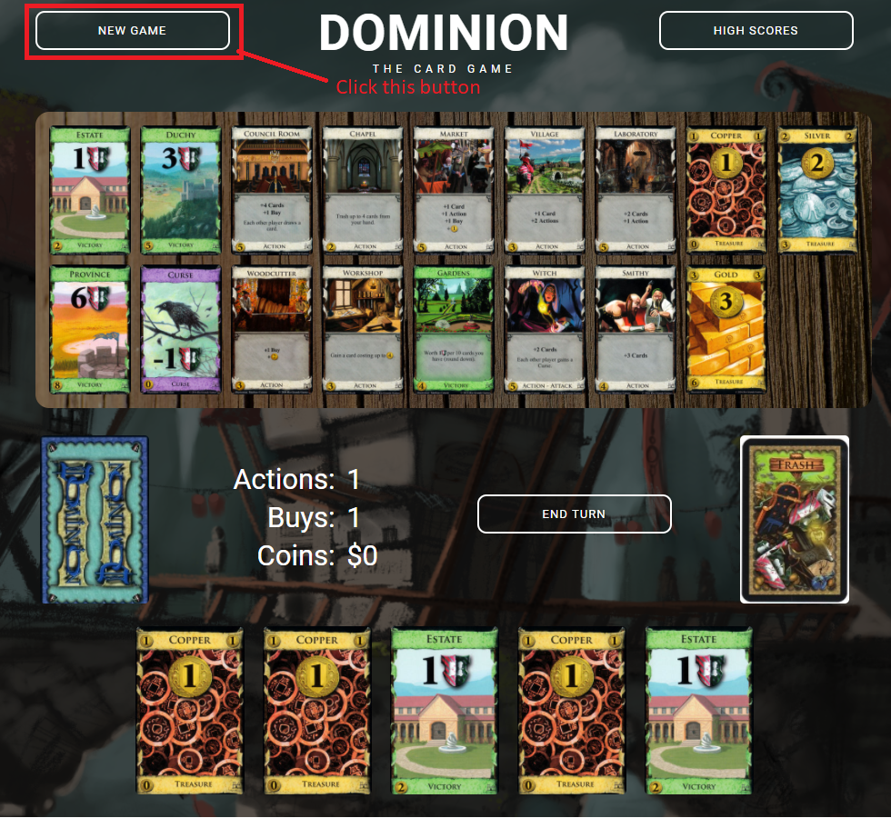

# How to play a card from your hand

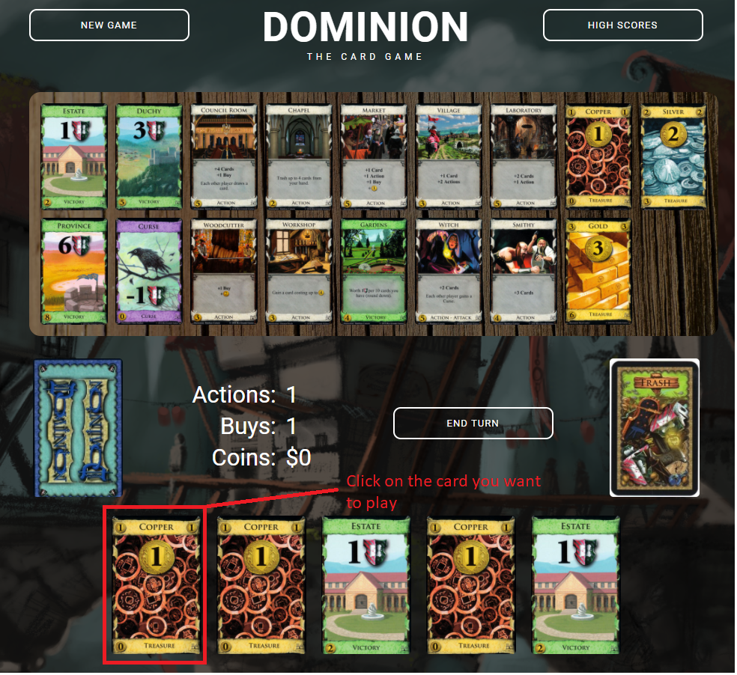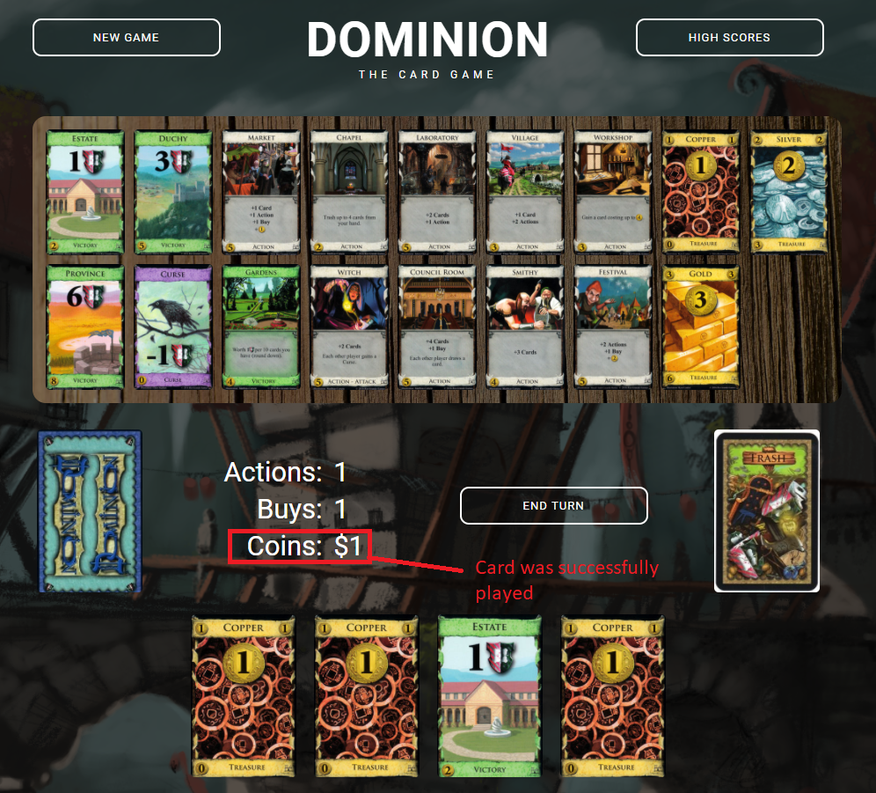

# How to Buy a Card from the Supply

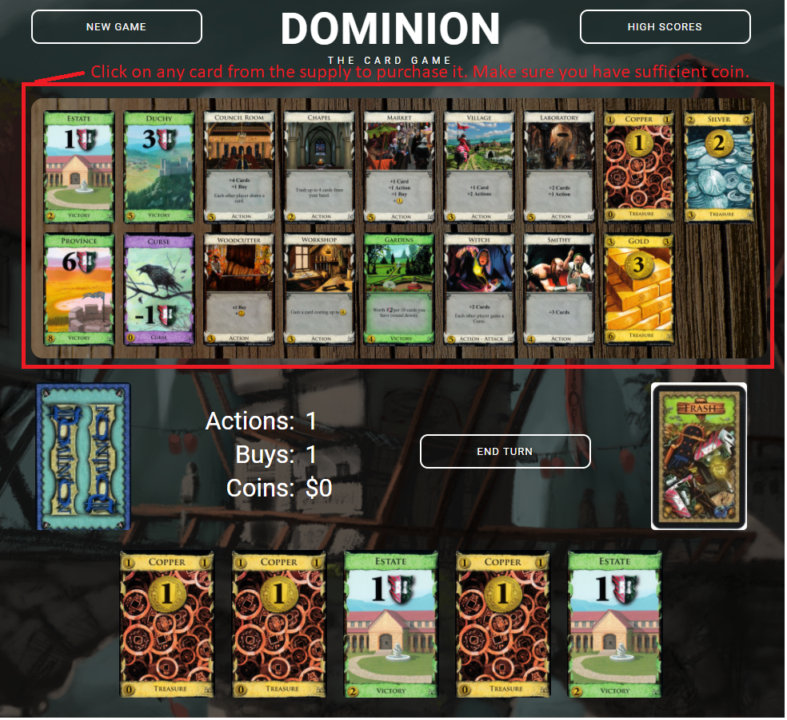

# How to Finish Your Turn

